REPORT

ON

FOUR WEEKS OF INTERNSHIP

Carried out on

**WEB DEVELOPMENT**

*Submitted to*

**NMAM INSTITUTE OF TECHNOLOGY, NITTE**

(An Autonomous Institution under VTU, Belagavi)

*In partial fulfilment of the requirements for the award of the*

Degree of Bachelor of Engineering

in

Information science & Engineering

*by*

**HITHANSH H SHENOY**

USN **4NM21IS054**

Under the guidance of

Dr Bola Sunil Kamath (Asst Professor Gd-III, NMAMIT)

Mr Pranav Pai Vernekar ( CEO, Bolt IoT )

Mr Ashwin Salgaocar ( Devops Engineer, Bolt IoT )



### 

### CERTIFICATE

*This is to certify that the “Internship report” submitted by* MR. HITHANSH H SHENOY bearing USN 4NM21IS054 *of 4th semester B.E., a bonafide student of NMAM Institute of Technology, Nitte, has undergone six weeks of internship on*

*“ WEB DEVELOPMENT ” during  Month February 2023 – March Month  2023 fulfilling the partial requirements for the award of degree of Bachelor of Engineering in Information Science & Engineering at NMAM Institute of Technology, Nitte****.***

**_____________________________ _________________________**

*Name and Signature of Mentor* *Signature of HOD*

(i)

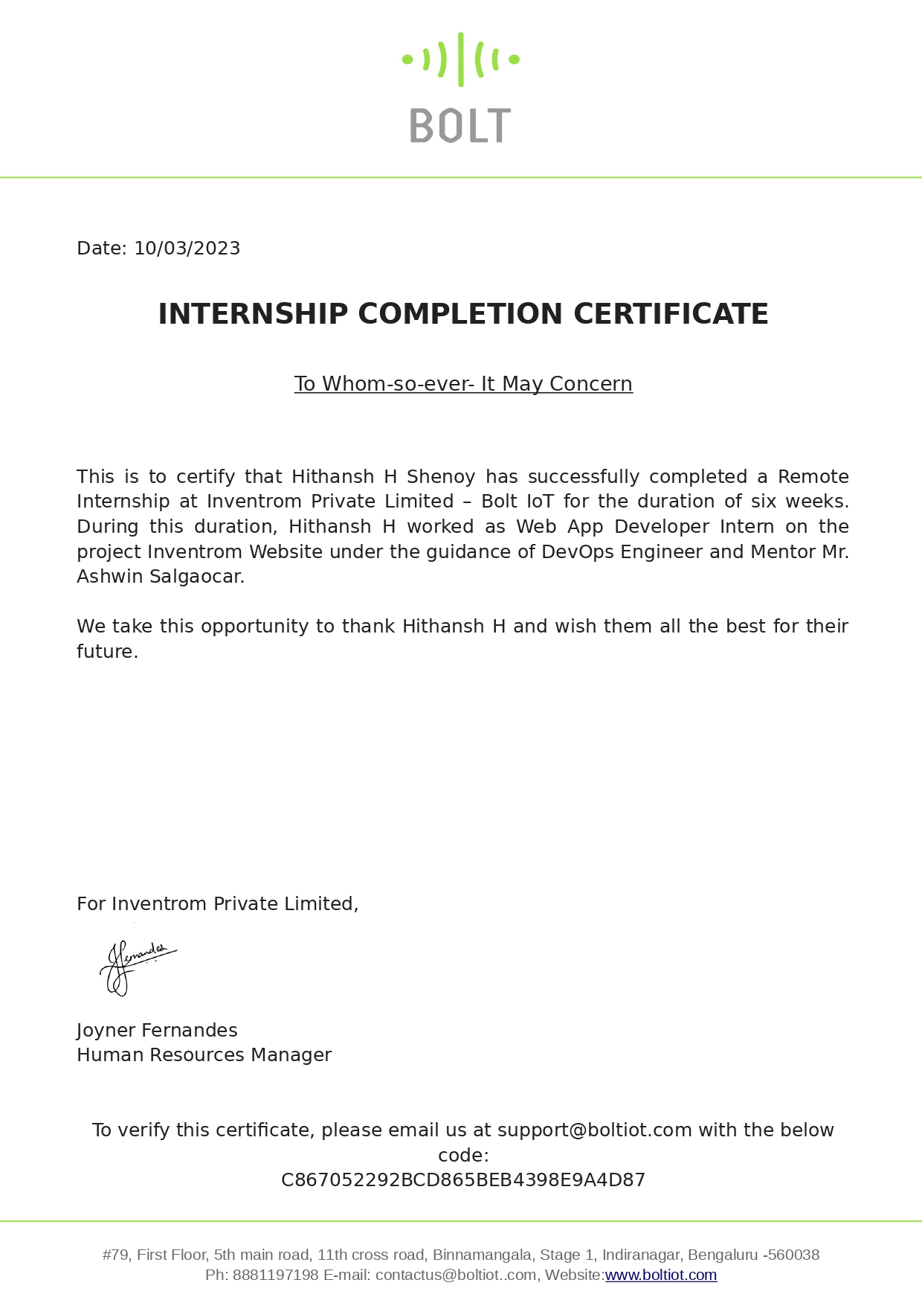

(ii)

***ACKNOWLEDGEMENT:***

First and foremost, I would like to extend my appreciation to Mr Pranav Pai Vernekar, CEO Bolt IoT, for their constant support and encouragement. Their expertise and knowledge in web development have been instrumental in shaping my skills and enhancing my understanding of HTML, CSS, and JavaScript.

I would like to express my deepest gratitude to Mr Rahul Singh and Mr Ashwin Salgaocar, Mentors at Bolt IoT for their invaluable guidance and mentorship during my internship. Their expertise, patience, and willingness to answer my countless questions have been truly commendable. They provided me with valuable insights, helped me overcome challenges, and continuously pushed me to improve my skills.

I would like to express my gratitude to the entire team at Bolt IoT for providing the necessary resources, materials, and online courses that laid the foundation for my web development skills. The well-structured curriculum and comprehensive learning materials were instrumental in building my understanding of HTML, CSS, and JavaScript.

I would like to thank Dr Bola Sunil Kamath ( Asst Professor Gd-III ) and NMAM Institute of Technology for their prompt and constructive feedback on my project. Their inputs and suggestions played a crucial role in refining my internship project. The collaborative environment fostered a positive learning experience, enabling me to grow both personally and professionally.

Lastly, I would also like to acknowledge the support I received from my fellow interns and colleagues. Their camaraderie and willingness to assist one another made the internship journey enjoyable and rewarding.

(iii)

***LIST OF CONTENTS:***

|  |  |
| --- | --- |
| Title | Page No. |
| Institute Certificate | (i) |
| Company Certificate | (ii) |
| Acknowledgement | (iii) |
| Table of Contents | (iv) |
| Abstract | 1 |
| 1. Company overview | 2 |
| 1. Course phase | 3-6 |
| 1. Internship phase | 7-13 |
| Conclusion | 14 |
| References | 15 |

(iv)

***ABSTRACT :***

This abstract provides a concise overview of my completion of the web development internship at Bolt IoT, focusing on the utilization of HTML, CSS, and JavaScript. Throughout the internship, I gained practical experience in web development and acquired essential skills in front-end development.

During the internship, I successfully completed various projects that allowed me to apply my knowledge of HTML, CSS, and JavaScript. These projects included creating responsive landing pages and building interactive web applications. By leveraging HTML and CSS, I designed visually appealing and user-friendly interfaces. JavaScript played a crucial role in enhancing the interactivity and dynamic functionality of the web applications.

Under the guidance of the experienced team at Bolt IoT, I expanded my understanding of front-end development best practices. I learned the importance of clean code structure, responsive design principles, and cross-browser compatibility. Additionally, I explored JavaScript libraries and frameworks such as jQuery and Bootstrap, which enabled me to streamline development tasks and enhance the user interface.

Throughout the internship, effective communication and collaboration with the team played a vital role in the successful completion of my projects. Regular feedback sessions and constructive critiques allowed me to refine my skills and deliver high-quality web solutions. The internship experience at Bolt IoT also emphasized the significance of meeting project deadlines and working efficiently in a professional environment.

1

***1.COMPANY OVERVIEW :***

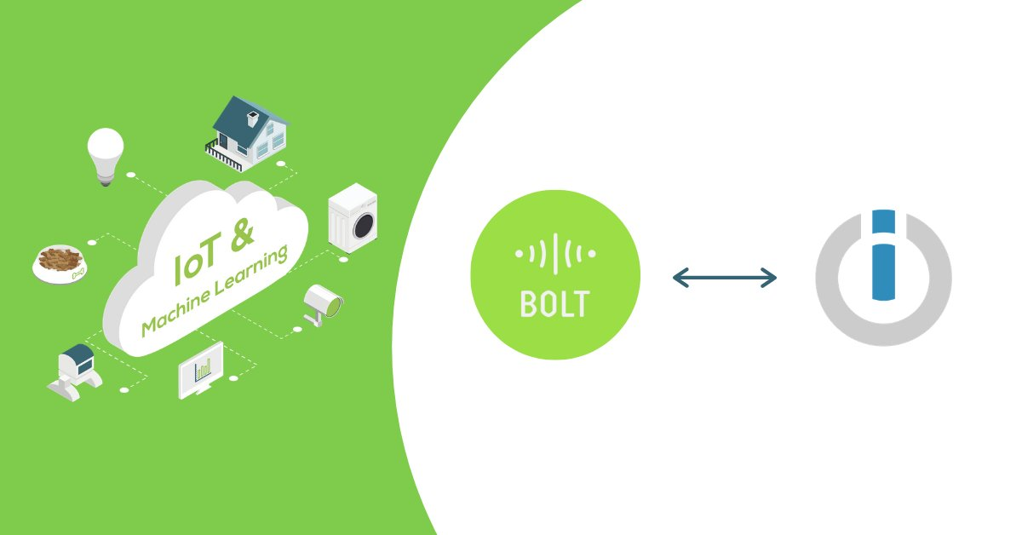

Bolt IoT, a leading company in the field of Internet of Things (IoT) solutions, provided me with the opportunity to undertake a web development internship. This internship allowed me to delve into the exciting world of web development using HTML, CSS, and JavaScript. Bolt IoT is renowned for its innovative IoT products, services, and training programs, making it an ideal platform for me to gain practical experience and knowledge in the web development domain.

Bolt IoT, founded by Mr. Pranav Pai Vernekar, is a prominent company in the field of web development using HTML, CSS, and JavaScript. Mr. Pranav Pai Vernekar serves as the Founder and CEO of Bolt IoT, playing a pivotal role in guiding the company towards success and innovation. Under his leadership, Bolt IoT has established itself as a leading provider of online courses and practical training in the web development domain.

Bolt IoT's mission is to empower individuals and organizations with the skills and tools necessary to thrive in the digital era. Their focus on IoT solutions has established them as a prominent player in the industry, and their commitment to education and skill development is evident through their comprehensive training programs. Mr. Pranav Pai Vernekar's vision for Bolt IoT is to provide aspiring web developers with the necessary knowledge and practical experience to excel in the industry.

2

***2.COURSE PHASE:***

***2.1 Curriculum overview & learning methodology :***

The Course phase of the web development internship at Bolt IoT spanned half a month and provided a comprehensive curriculum that covered all essential aspects of web development using HTML, CSS, and JavaScript. This phase aimed to equip interns with a strong foundation in these key technologies and ensure a holistic understanding of web development principles and practices.

Bolt IoT employed an effective and engaging online learning platform to deliver the course materials. The platform incorporated a variety of resources, including videos, animations, and interactive quizzes, to facilitate effective learning and retention of the concepts. This blended approach allowed interns to learn at their own pace while providing ample opportunities for hands-on practice and reinforcement of the newly acquired knowledge.

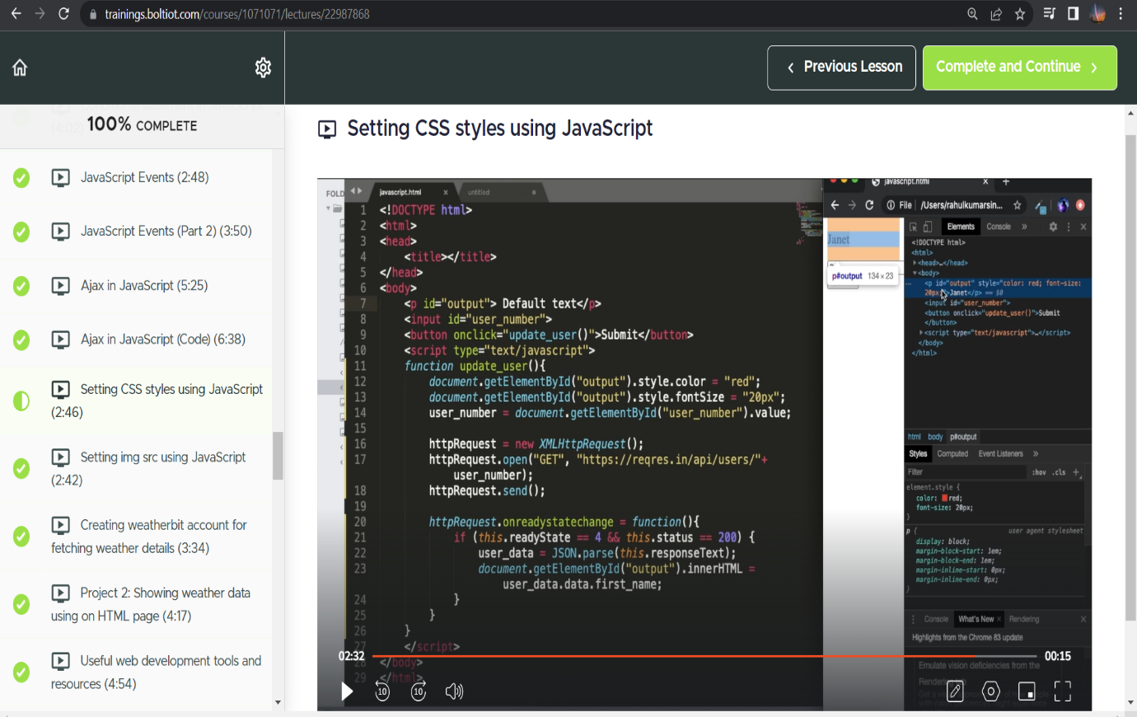

3

***2.2 Module-wise Topics:***

During the course phase, interns were introduced to various modules covering the fundamentals and advanced concepts of HTML, CSS, and JavaScript. The course curriculum provided a comprehensive understanding of web development principles and equipped interns with the necessary skills to undertake practical projects. The following is an overview of the module-wise topics covered

1. **HTML:**

* Introduction to HTML and its structure
* HTML tags, elements, and attributes
* Text formatting and semantic HTML
* Working with links, images, and media
* Tables, forms, and input validation
* HTML5 features and APIs

1. **CSS:**

* Introduction to CSS and its syntax
* CSS selectors and specificity
* Box model and layout techniques
* Styling text, backgrounds, and borders
* CSS transitions, animations, and transformations
* Responsive design and media queries

1. **JavaScript:**

* Introduction to JavaScript and its role in web development
* JavaScript variables, data types, and operators
* Control structures and loops
* Functions, objects, and arrays
* DOM manipulation and event handling
* AJAX, JSON, and API integration

4

***2.3 Mini Projects and Live Demonstrations:***

To reinforce the concepts learned during each module, mini projects were assigned to interns, providing practical hands-on experience. Live demonstrations were conducted to showcase the implementation of these projects. The following mini projects were undertaken during the course phase:

1. Weather Data Using API: In this project, interns learned how to retrieve weather data using an API. They used HTML, CSS, and JavaScript to create a weather information website that displayed real-time weather data based on user inputs or location detection.
2. Movie Finder Website: Interns developed a movie finder website using HTML, CSS, and JavaScript. The website allowed users to search for movies, view details, and access relevant information such as ratings, cast, and synopsis.
3. Expense Tracker Website: This project focused on building an expense tracker website to help users manage their expenses. Interns utilized HTML, CSS, and JavaScript to create a user-friendly interface that allowed users to add, categorize, and track their expenses.

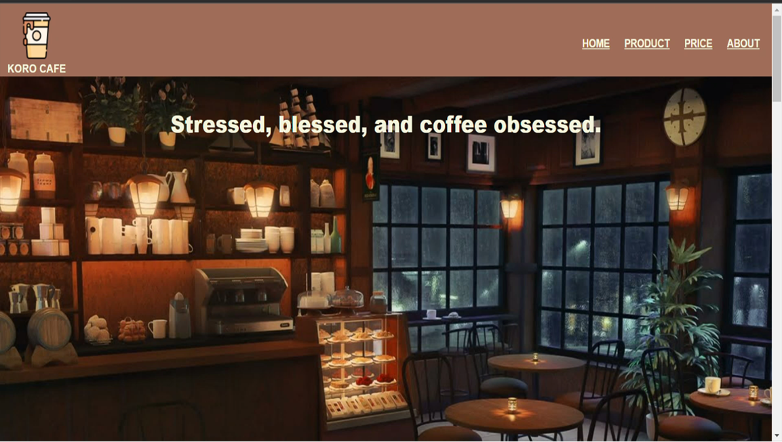

5

1. The coffee shop website developed during the internship phase was an engaging and visually appealing online platform that showcased the offerings and ambiance of a fictional coffee shop. The website featured a captivating homepage with enticing images of freshly brewed coffee, a welcoming navigation bar, and a prominent call-to-action to attract potential customers. It included sections that highlighted the menu, special promotions, and the coffee shop's story. Users could explore various coffee options, learn about the origins of the beans, and even place orders through an intuitive and user-friendly interface.
2. The photo gallery website developed as a mini project during the internship showcased the interns' proficiency for creating an engaging visual experience. The website provided a platform for users to explore and appreciate a collection of captivating photographs. It featured a clean and modern design, with a grid layout to display the photos in an organized manner. Users could navigate through different categories, view individual photos in a larger size, and even leave comments or share the images on social media platforms. The photo gallery website incorporated responsive design techniques to ensure seamless viewing across various devices, providing a user-friendly experience.

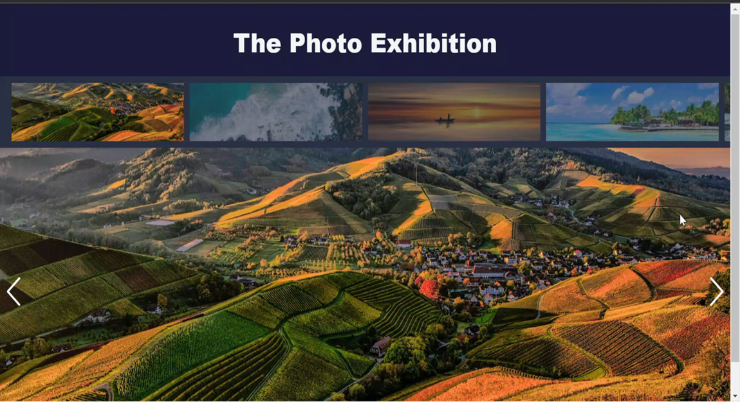

6

***3. INTERNSHIP PHASE:***

***3.1.Website Design:***

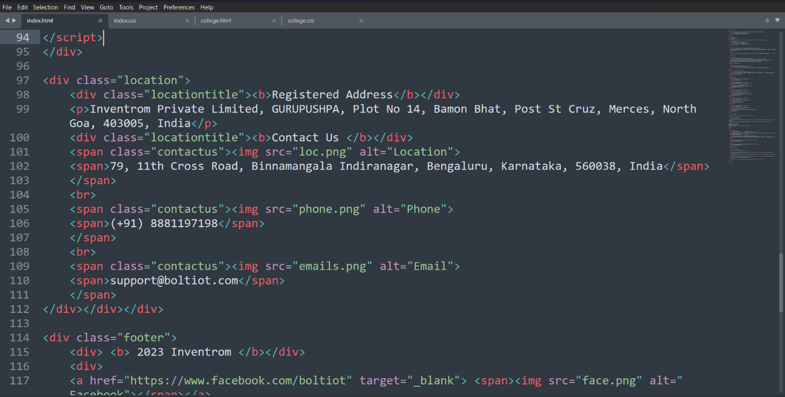

1. **A structured process to design and develop the website :**
2. Wireframing and Mockups: Interns created wireframes and mockups to plan the layout and structure of the website. Wireframing allowed them to define the placement of different elements and sections on each webpage, while mockups helped visualize the overall look and feel of the website.
3. Visual Design: Based on the wireframes and mockups, interns proceeded to design the visual elements of the website. They leveraged their knowledge of HTML and CSS to create an appealing and cohesive design, incorporating Bolt IoT's branding elements such as colors, fonts, and logo.
4. User Interface Development: Using HTML and CSS, interns translated the visual design into functional webpages. They implemented the necessary HTML markup and CSS styles to bring the design to life, ensuring the website was aesthetically pleasing, user-friendly, and responsive across different devices and screen sizes.

7

1. Interactive Elements: Interns utilized JavaScript to add interactivity and dynamic functionality to the website design. They incorporated features such as dropdown menus, sliders, interactive forms, and animations to enhance the user experience and engagement.
2. Content Integration: Alongside the design and development, interns integrated relevant content into the website. This involved writing engaging copy, incorporating high-quality images and videos, and optimizing the website for search engine optimization (SEO) to improve its visibility on search engines.
3. Testing and Iteration: Interns thoroughly tested the website design to ensure its functionality, responsiveness, and cross-browser compatibility. They addressed any bugs or issues that arose during the testing phase and made necessary iterations to refine the design and improve user experience.
4. **Website Breakdown :**

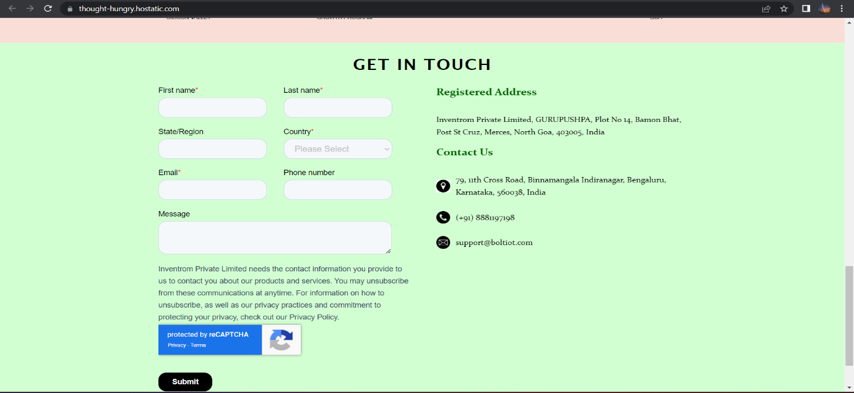

8

* During the internship phase, I undertook the task of designing a replica website for Bolt IoT using HTML, CSS, and JavaScript. The objective was to create a visually appealing and functional website that showcased Bolt IoT's products, services, and company information.
* The website design began with a navigation bar located at the top of the page. It included links to various sections such as "Awards," "Contacts," and "About Us," along with the Bolt IoT logo, providing easy navigation for visitors.
* The opening page of the website incorporated background images that complemented Bolt IoT's branding and aesthetics. Additionally, a separate link was included that directed users to Bolt IoT's original website, allowing them to explore more about the company.
* The "About Us" section served as a comprehensive introduction to Bolt IoT. It included detailed company information, mission, and vision statements. This section aimed to provide visitors with a deeper understanding of Bolt IoT's values, expertise, and goals.
* To highlight Bolt IoT's achievements, the "Awards" section was created. It listed all the awards received by Bolt IoT from various start-ups and research organizations. This section aimed to showcase Bolt IoT's recognition and credibility within the industry
* The "Contact Us" section was designed to facilitate easy communication between Bolt IoT and its visitors. It included contact details such as email, phone number, and address. Additionally, a contact form was implemented, allowing users to fill in their details and reach out to Bolt IoT directly.

9

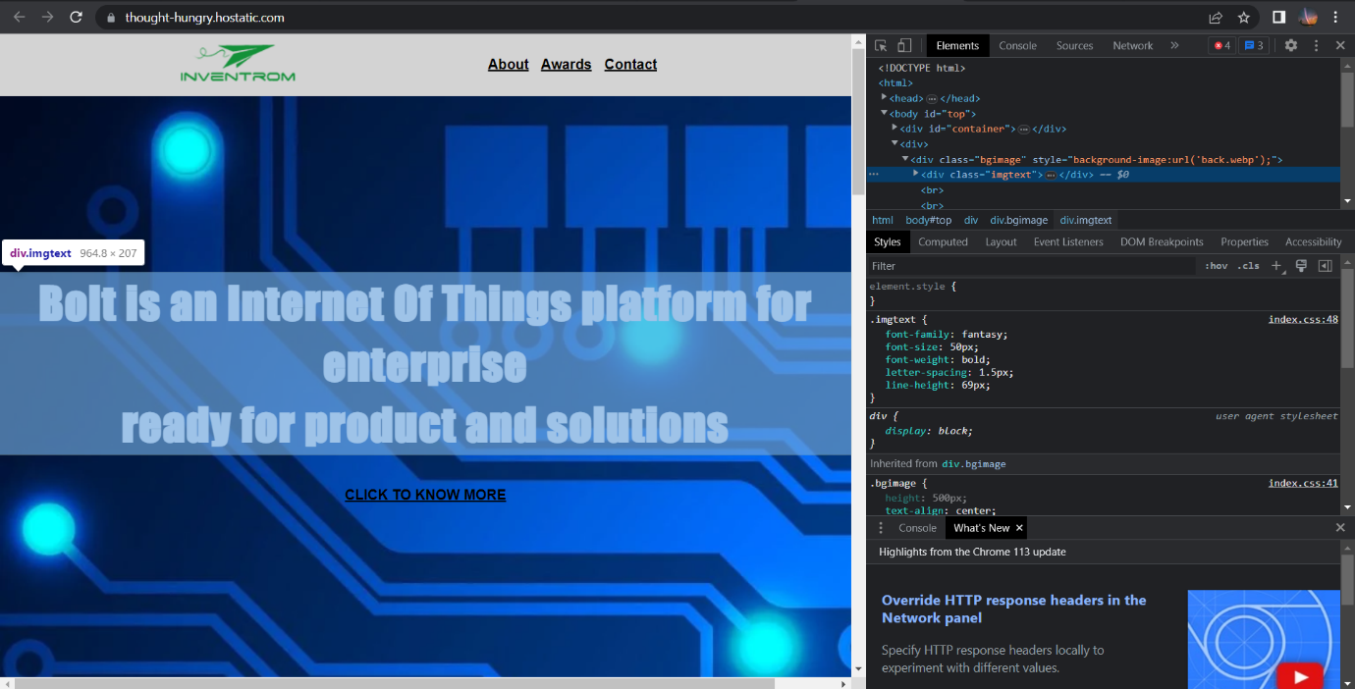

* The footer section of the website featured various social media links, including WhatsApp, Instagram, and Twitter. These links provided visitors with an opportunity to connect with Bolt IoT through different social media platforms, enhancing engagement and interaction.
* Throughout the website design process, attention was paid to the overall layout, color scheme, and user experience. Responsive design techniques were implemented to ensure optimal viewing experiences across different devices and screen sizes. Furthermore, accessibility standards and best practices were followed to ensure the website was inclusive and user-friendly.
* The inspect tool, available in modern web browsers, played a crucial role in fabricating and furnishing websites during the course phase. Interns were encouraged to leverage the inspect tool to analyse and manipulate website elements, styles, and layouts. This allowed them to experiment with different design elements, identify and rectify issues, and enhance the overall appearance and functionality of their projects. Through the inspect tool, interns gained practical insights into the structure and styling of existing websites, enabling them to refine their own projects and acquire a deeper understanding of web development techniques.

10

1. **Version Control using GitHub:**

During the website development phase, interns utilized version control systems, particularly GitHub, to manage their codebase efficiently. GitHub provided a collaborative platform for tracking changes, coordinating work among team members, and ensuring code integrity.

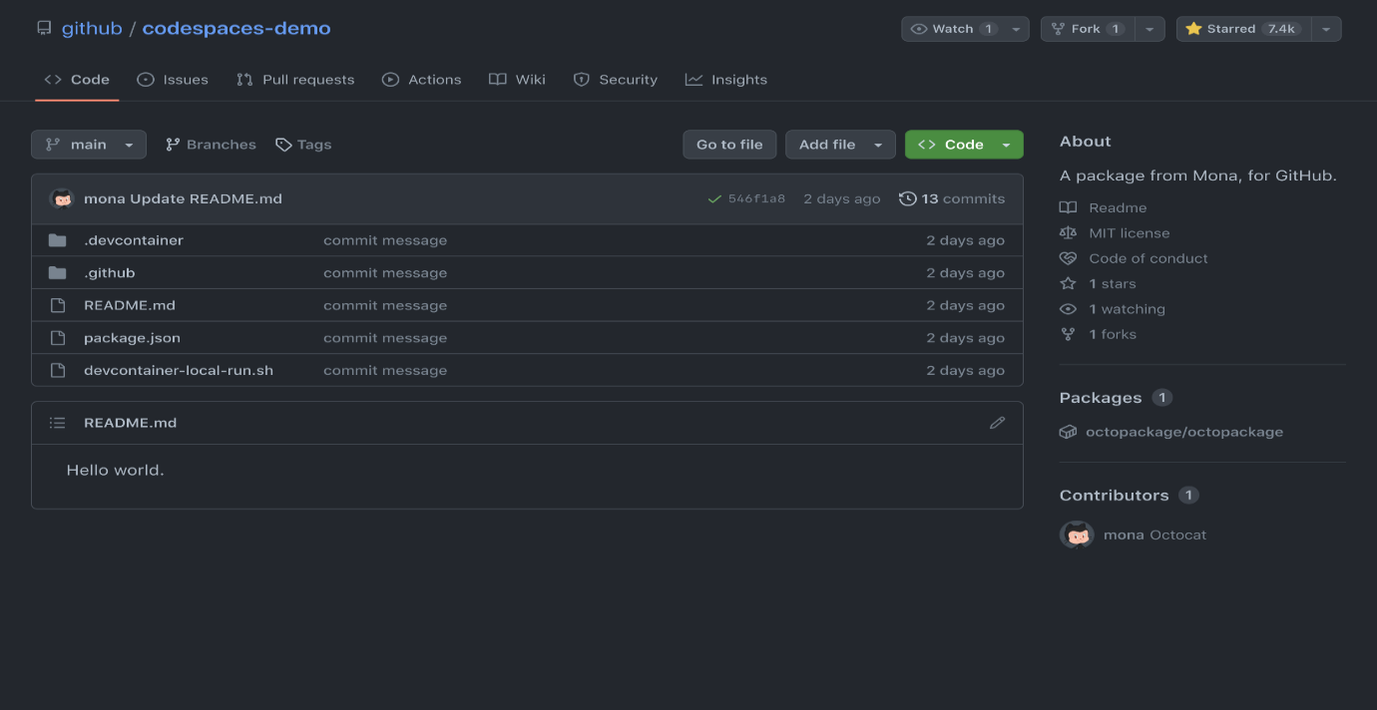

1. Repository Setup: Interns created a Git repository on GitHub to host their website project. This allowed them to establish a central repository where they could store, manage, and track changes to their codebase.
2. Branching Strategy: They followed a branching strategy, such as the Gitflow workflow, to facilitate parallel development and maintain a clean and organized codebase. They created different branches for features, bug fixes, and other development tasks, ensuring that the main branch remained stable.
3. Pull Requests and Code Reviews: Interns utilized pull requests to propose changes and additions to the main codebase. They initiated pull requests for merging their feature branches into the main branch, allowing for code reviews by peers or supervisors. This facilitated collaboration, feedback, and ensured the quality of the codebase.

11

1. Issue Tracking: They utilized GitHub's issue tracking system to report and track bugs, feature requests, or other project-related tasks. This allowed for efficient communication and coordination among team members, ensuring that issues were promptly addressed and resolved.
2. **Hosting solutions :**

After completing the website development, interns needed to host their website to make it accessible on the internet. They explored various hosting platforms that offer reliable infrastructure and services to deploy and manage websites. Cloud hosting utilizes a network of interconnected servers to provide scalable and flexible hosting solutions.

* Google Cloud Platform offers a comprehensive set of hosting solutions that provide a reliable and scalable infrastructure for hosting websites and web applications.
* GCP provides Google Cloud Storage, which offers object storage for hosting static content such as HTML, CSS, JavaScript, and media files. It provides a scalable and cost-effective solution for storing and serving website assets globally. Load Balancing: GCP offers load balancing solutions to distribute incoming website traffic across multiple instances to ensure high availability and optimal performance. It automatically scales resources based on demand, handling traffic spikes effectively.
* GCP provides managed database services such as Cloud SQL (MySQL and PostgreSQL) and Cloud Firestore (NoSQL) for storing and retrieving data. These services offer scalability, automatic backups, and replication, ensuring data integrity and reliability.
* GCP offers robust security features, including encryption at rest and in transit, identity and access management controls, and regular security audits. It also provides monitoring and logging tools to track website performance, identify issues, and ensure the overall health of the hosting environment.

12

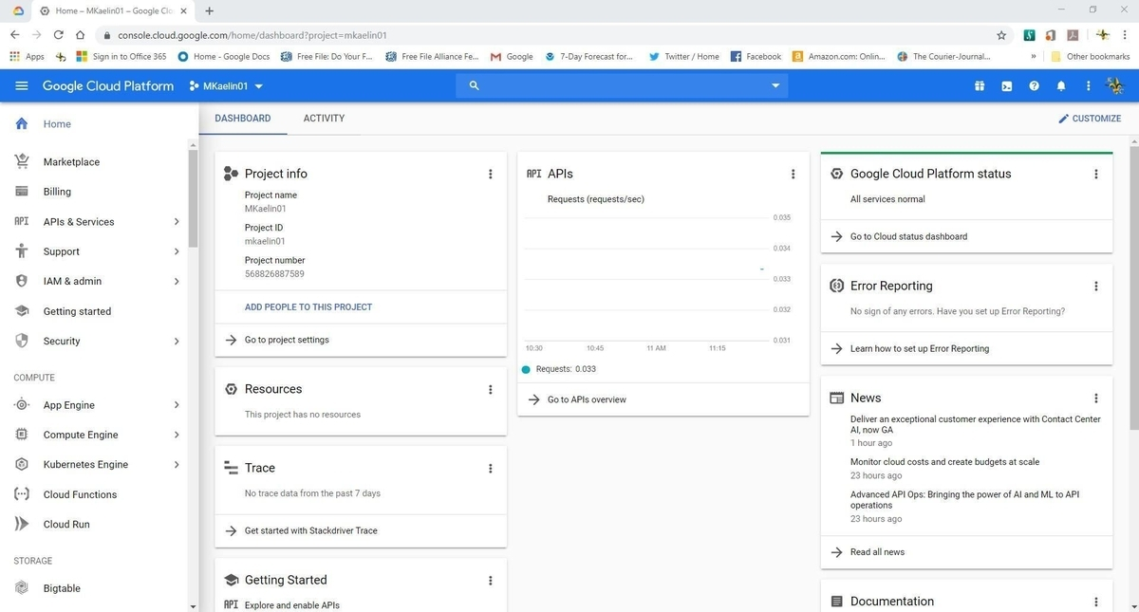

***3.3 Presentation & Documentation :***

Interns prepared a comprehensive presentation that highlighted the entire web design process for the Bolt IoT project. They structured the presentation to introduce the project, cover various stages of development, and provide insights into design decisions. Visual elements, live demonstrations, and explanations of technical aspects were incorporated to engage the audience and showcase their skills. The presentation served as a platform to demonstrate the website's features, functionality, and the intern's problem-solving abilities.

In addition to the presentation, interns prepared detailed documentation that provided a comprehensive understanding of the website project. The documentation included an overview of the project, technical details of the implementation, descriptions of features and functionalities, installation and setup instructions, troubleshooting steps, and recommendations for future maintenance and enhancements. The documentation served as a valuable resource for future reference and ensured that the knowledge and insights gained during the internship were well-documented and accessible for the Bolt IoT website's ongoing maintenance and potential updates.

13

***CONCLUSION :***

The web development internship at Bolt IoT has been a transformative and rewarding experience, equipping me with valuable skills, knowledge, and practical exposure in the field of web development using HTML, CSS, and JavaScript. Throughout the course phase, I gained a comprehensive understanding of the core concepts and techniques through a well-structured curriculum and engaging online learning platform. The mini-projects provided hands-on experience, allowing me to apply my knowledge in real-world scenarios.

Transitioning into the internship phase, I had the opportunity to work on a website design project for Bolt IoT. Leveraging the skills and knowledge acquired during the course phase, I dedicated myself to creating an engaging and responsive website that effectively showcased Bolt IoT’s products and services. The project allowed me to demonstrate my proficiency in HTML, CSS, and JavaScript, while adhering to industry best practices and incorporating modern design principles.

The video presentation I prepared showcased my ability to effectively communicate and present my work, highlighting the key features and functionality of the website. Additionally, the experience video provided a personal reflection on my journey throughout the internship, emphasizing the growth, challenges, and learning experiences encountered along the way.

The web development internship not only enhanced my technical skills but also nurtured important soft skills such as problem-solving, collaboration, and effective communication. The experience of working on a real-world project and being a part of a professional environment has significantly contributed to my personal and professional growth.

14

***REFERENCES :***

* Coursera:

Website: <https://www.coursera.org>

* edX:

Website: <https://www.edx.org>

* LinkedIn Learning:

Website: <https://www.linkedin.com/learning>

* GitHub:

Website: <https://github.com>

* W3Schools: Web Development Tutorials and References.

Website: <https://www.w3schools.com/>

* FreeCodeCamp: Learn to Code for Free – Web Development Courses.

Website: <https://www.freecodecamp.org/>

* Bolt IoT: Official Website.

Website: <https://www.boltiot.com/>

* Stack Overflow: Online Community for Programmers and Developers.

Website: <https://stackoverflow.com/>

15